**KICKSTARTER CAMPAIGN**

August 16, 2018

**Background**

Over two billion dollars have been raised using the massively successful crowdfunding service, Kickstarter, but not every project has found success. Of the over 300,000 projects launched on Kickstarter, only a third have made it through the funding process with a positive outcome.

Since getting funded on Kickstarter requires meeting or exceeding the project's initial goal, many organizations spend months looking through past projects in an attempt to discover some trick to finding success.

The report below summarizes these findings and provides an explanation of the performance of the more than four thousand projects 2009 to 2017.

**Analysis**

Over the nine-year period the outcome of donations showed 2,185 projects as successful, 1530 failed, 349 cancelled and 50 still live. Chart 1 below shows the project state distribution by category with theater having the largest bucket of projects.

Chart 1.

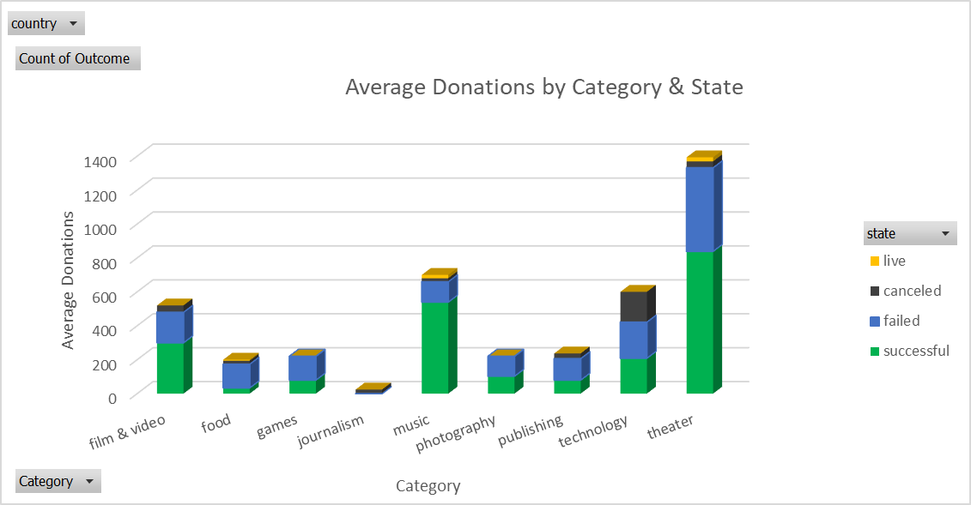

When looking at the subcategories for each of the overarching parent categories plays reportedly had 1066 projects aligned of which 694 were successful. The correlation between theater and plays is a direct relationship and explains the consistent success rate in the two buckets. There wasn’t enough information from the data set given to determine the reasons for backer support. Additionally, with the number of countries represented having projects skewed towards the US it may be that the Americans prefer theater than other countries that form part of the population (countries represented in the data).

Regression testing as well as correlation scatterplots could shed some light on what variables are dependent on the state of each project. Again, the data set did not clearly capture why backers were supporting each category but merely just showed raw counts and dollars supporting each project category. It would have been good to capture further detail on the genre of each product as this might be more indicative reasoning as to preferences being the reason for a successful project.

**Conclusion**

Over the nine years there was a steady increase in the monetary value for each pledge. Years 2009 through 2013 showed the US as having all the pledge dollars assigned. In 2014 however, the number of projects having pledges were more evenly spread among each state.

The average outcomes on a monthly bases was consistent Jan – Dec of each calendar year with ~ 338 project averages by state assigned per month. The highest success was seen in the month of May, with Feb, Jun and July also having high success states. This could indicate that Summer and Spring have the best outcomes for project releases. Notably goals targeted for 1000 to 4,999 had 932 of 2,185 successful states which may be the best target going forward for future project. Chart 2 below shows this relationship with Table 1 showing all the goal targets and their states.

**Chart 2**

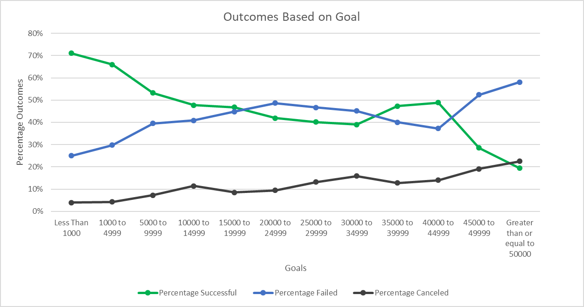

**Table 1**

**Questions**

*What are three conclusions we can make about Kickstarter campaigns given the provided data?*

* The campaigns were 54% successful in meeting their pledge goals. With the highest support in the theater category.
* Years 2014 to 2016 were the most successful with only slightly marked gains in year 2009 to 2013 and a slight decline in 2017.
* The theater category held 20% of the overall distribution in categories and had the most successful outcome.
* Countries participating in the campaign were world-wide with the US having 80% of backers followed by Great Britain 11%
* On average the days for the start of the conversion to the end of the conversion yielded the most results at 60 days.

*What are some of the limitations of this dataset?*

* Not enough information on backer ratings were provided. While the number of backers supporting each subcategory is listed it is unclear how these were ranked.
* The Category and subcategory groupings were too broad. Simply stating just film, video or television was not enough to deduce a correlation to category and pledge
* It would be good to have the type of genre to help see trends into why pledges may have been more for one category as opposed to another
* Currency of pledges needs to be all converted to US dollars or some unique currency to be able to measure the overall value of each pledge.

*What are some other possible tables/graphs that we could create?*

* Correlation graphs (scatter plot) showing the relationship between pledges and some other variable.
* Regression analysis to see what variables the pledges were dependent on. What drove backers to pledge on certain categories?
* Create additional pivot table showing pledges by year with donations normalized to a consistent currency.